Bits Pay: Platform Architecture and Data Flow
v4 · Oct 14, 2026 · @Ahmad Naqibul Arefin (v3: Oct 14, 2026; v2: Oct 12, 2026; v1: Oct 8, 2026)
Changes in v4. MVP scope and bill payment / mobile recharge flows added; GL journal export removed. The new Section 3 sets out the MVP, Section 12.1 adds the bill payment and mobile recharge flow, and the general ledger (Section 7) now produces the trial balance, balance sheet and P&L only. Later sections are renumbered by one.

1. Introduction
Bits Pay is a mobile financial service (MFS) built to handle 20,000+ transactions per second (TPS) at peak, on servers in Bangladesh. It uses TigerBeetle as the money ledger, Postgres 18 for all other data, and Kafka with Debezium to share events between services.
This document is written for engineers, product owners and managers, including readers new to payment systems. Every technical idea comes with a plain-English comparison and a worked example. Technical terms are explained the first time they appear, and the glossary at the end collects them.
How to read it. Section 3 sets out what the MVP includes. Sections 4 to 9 explain the building blocks, including the general ledger that keeps the official books (Section 7). Sections 10 to 12 follow real transactions through the system, step by step. Sections 13 to 18 cover the supporting design: events, caching, failures, deployment, security and operations.
The example used throughout. One story runs through the whole document. The fee and VAT amounts are illustrative, not a pricing proposal.
Person | Role | Example
Rahim | Customer, smartphone app | Sends 500 Tk to Karim
Karim | Customer, basic phone (USSD) | Receives the 500 Tk by SMS
Salma | Agent with a shop in Mirpur | Gives Karim cash when he cashes out
Nirob Store | Merchant with a QR code | Rahim pays for groceries
Bits Pay | The platform | Charges a 5 Tk fee + 0.75 Tk VAT (15% of the fee)
The one idea to remember. Money moves in one place only: the TigerBeetle ledger. Every other part of the system either asks the ledger, prepares a request for it, or reacts after it has moved money. The general ledger keeps the Operator's books, but it only records what the ledger has already posted.

2. Scope, requirements and assumptions
The first release covers every major MFS product, must survive peak days like Eid, and runs entirely in Bangladeshi data centers. A smaller MVP goes live before it (Section 3).
Products in scope
Product group | What customers do | Example
P2P and agent cash | Send money; deposit or withdraw cash at an agent | Rahim sends 500 Tk to Karim; Karim cashes out at Salma's shop
Merchant and bills | Pay by QR; pay utility bills; recharge a mobile | Rahim scans Nirob Store's QR; pays his electricity bill; tops up his phone
Bank, card, disbursement | Add money from bank or card; companies pay salaries in bulk | A garment factory pays 5,000 workers at once
Remittance, savings, loans, interop | Receive money from abroad; save or borrow through partner banks; send to any bank via NPSB or Binimoy | Rahim's brother in Dubai sends him money
Key requirements
Requirement | Target
Peak throughput | 20,000+ business transactions per second
Response time for P2P, cash-out, merchant pay | About 300 ms at p99 (99 of 100 requests faster than this)
Money accuracy | Zero tolerance: no money created, lost or moved twice
Availability | Survives the loss of a server, a rack or a whole data center
Hosting | On-premises, in Bangladesh
Assumptions
- The customer base is large, about 80 million wallets at maturity. All sizing in this document uses that figure.
- Bangladesh Bank rules apply: every taka of e-money must be backed by money held in trust bank accounts, and suspicious activity is reported to BFIU (the Bangladesh Financial Intelligence Unit).
- The team builds on Java 25, Spring Boot 4.1, Kafka and Debezium.
- Recovery targets (RPO and RTO) are not yet agreed. Section 19 lists this as an open decision.

3. MVP scope
The MVP is a smaller first release that goes live before R1 (SRS v1.2, 14 Oct 2026). It proves the whole money path, from the app to TigerBeetle to the books, with six customer features. It calls no outside network: every partner the MVP needs is simulated inside Bits Pay.
The six MVP features
- P2P send money. Rahim sends 500 Tk to Karim (Section 10).
- Merchant payment. On-us Bangla QR or merchant number only, settled to the merchant wallet. Off-us scheme routing and bank settlement are R1.
- Merchant refund. Full or partial, linked to the original payment; the total refunded never exceeds the original amount.
- Agent cash-in and customer-initiated cash-out. No OTP or step-up in the MVP; the edge passes trusted actor headers.
- Bill payment. Against an internal biller catalogue, confirmed by a simulated biller (Section 12.1).
- Mobile recharge. Top-up for the five mobile operators, confirmed by the same simulated provider (Section 12.1).
Behind these features the MVP also runs the wallet and ledger core, e-money issuance and agent float, basic KYC with screening, limits and tiers, fees and VAT, in-line agent commission, support reversals, the general ledger books, notifications and admin governance.
Services and their MVP role
Service | MVP role | What it does in the MVP
ledger-service | MVP active | The only door to TigerBeetle. Payment commands 1-6, reversal and the new commands 18 post-bill-payment and 19 post-recharge; account type 150 BILLER_WALLET.
transaction-service | MVP active | Orchestrates P2P, merchant payment and refund, cash-in, cash-out, BILL_PAY and RECHARGE. Hosts the SimulatedBillerClient.
wallet-service | MVP active | Wallets, partners and the internal biller catalogue (partner type BILLER, wallet type B); writes wallet status and biller keys to Redis.
limits-risk-service | MVP active | Tier limits on every payment, including the BILL_PAY and RECHARGE limits; risk evaluation.
pricing-service | MVP active (campaign off) | Fees, VAT and in-line agent commission, including PLN-BILL-STD and PLN-RECHARGE-NONE. Campaigns are switched off.
treasury-service | MVP active (issuance and float only) | E-money issuance against trust deposits and agent float (FLOAT_TRANSFER).
compliance-service | MVP active (basic KYC/screening) | Basic KYC and compliance screening, without an e-KYC provider.
support-service | MVP active (reversals) | Reversals and wrong-transfer handling.
admin-service | MVP active | Reference data, FEATURE switches, maker-checker approvals and audit.
general-ledger-service | MVP active (GL-R1a) | The books: day, month and year close; trial balance, balance sheet and P&L. No journal file export.
disbursement-service | Out of MVP (R1+) | Salary and bulk disbursement, scheduled transfer and request money.
finance-ops-service | Out of MVP (R1+) | Reconciliation and reporting.
What is simulated or switched off
Outside system | In the MVP
NPSB, Binimoy, wallet-to-bank, add money | Off. Interop arrives in R1.
ekPay and bill aggregators | Simulated. The SimulatedBillerClient confirms bills inside the transaction service (bitspay.billers.mode=SIMULATED); no outbound call.
Telco or recharge aggregator | Simulated by the same client; the operator comes from the MSISDN prefix.
Bangla QR switch (off-us QR) | Off. On-us Bangla QR and merchant number only; settlement to the merchant wallet.
e-KYC provider | Off. Basic KYC with compliance screening.
USSD | Off. Customer app and agent app only.
SIEM | Off in the MVP.
Because no MVP customer flow waits on an outside system, the hold pattern of Section 11 is not used until R1.
FEATURE switches (admin service)
State in the MVP | Switches
Enabled | P2P, CASH_IN, CASH_OUT, MERCHANT_PAYMENT, MERCHANT_REFUND, FLOAT_TRANSFER, REVERSAL, BILL_PAY, RECHARGE
Disabled | DISBURSEMENT, SCHEDULED_TRANSFER, REQUEST_MONEY, CAMPAIGN, ADD_MONEY, WALLET_TO_BANK, REMITTANCE, CARD, OFF_US_QR
Out of the MVP (R1 and later): disbursement, scheduled transfer and request money, campaigns, finance-ops reconciliation and reporting, interop, ekPay and aggregator integration, remittance, card, off-us QR, agent-assisted bill pay and recharge, and USSD.

4. Architecture overview
Bits Pay has six layers, and it helps to picture them as a busy bank branch that never closes. Customers come in through a door, pass security, are served by clerks, and the clerks record results in storage. A back office tidies up afterwards, and some work goes out to other banks.
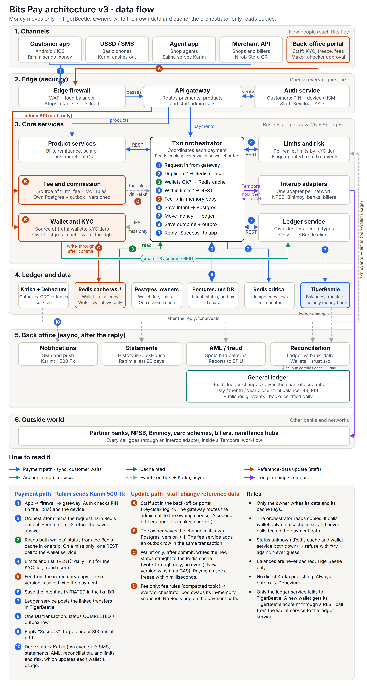
Bits Pay architecture v3 · six layers, the payment path (1–10), the reference-data update path (A–D), new-wallet account setup and the general ledger
Read it top to bottom. Blue arrows (1–10) are one payment, in the order of Section 10. The API gateway sends P2P, cash and QR requests straight to the orchestrator, and bills, remittance and salary requests to the product services, which call the orchestrator through its REST API to move money. The orchestrator calls limits and risk over REST on every payment, and starts a Temporal workflow (purple) when a partner network is involved. It never waits on the wallet or fee services: it reads wallet status from the Redis cache (green) and fee rules from its own memory. Orange arrows (A–D) show how that reference data changes. Staff use the back-office portal, which goes through the same edge as customers; the gateway routes the admin call to the owning service. The owner saves the change in its own Postgres. The wallet service then writes the new status straight to Redis (write-through only) and publishes no event. The fee service saves an outbox row with the change, and fee rules travel on fee.rules to every orchestrator pod's memory. When a new wallet opens, the wallet service calls the ledger service over REST to create its TigerBeetle account (teal). Only the ledger service talks to TigerBeetle. The back office reacts afterwards through Kafka (grey dashed), and limits and risk also consumes txn.events from the orchestrator's outbox to update each wallet's limit usage. In the back office, the general ledger reads ledger.changes, is certified every day by reconciliation's tie-out, and produces the trial balance, balance sheet and P&L (Section 7). In the MVP, bill payment and mobile recharge go straight to the transaction service and a simulated biller stands in for the outside network (Section 12.1).
Layer | In the bank branch | Technical parts | Its job
1. Channels | Front doors | Customer app, USSD/SMS, agent app, merchant API | Let people reach the system in different ways
2. Edge | Security desk | Load balancer, WAF, API gateway, auth service | Block attackers, check identity, route requests
3. Core services | Clerks | Transaction orchestrator, ledger service, wallet and KYC, limits and risk, fee and commission, product services, interop adapters | Make the business decisions
4. Ledger and data | Vault and filing cabinets | TigerBeetle, Postgres 18, Redis, Kafka with Debezium | Store money, records and events
5. Async consumers | Back office | Notifications, statements, AML/fraud, reconciliation, general ledger | React after a payment, without making the customer wait; keep the official books
6. External networks | Other banks | Partner banks, NPSB, Binimoy, card schemes, billers, remittance hubs, BFIU | Move money in and out of Bits Pay
Why split the system into many small services? Each service (also called a microservice) does one job and owns its own database. One team can change bill payment without risking send money. A busy service, such as the orchestrator on Eid, can be given more servers on its own.
Example. When Rahim sends 500 Tk to Karim, his request enters through the customer app (layer 1), is checked at the edge (layer 2), and is handled by the orchestrator (layer 3). The orchestrator asks the ledger service (layer 3) to move the money, and it moves in TigerBeetle (layer 4). Karim's SMS is sent by the back office (layer 5). No external network (layer 6) is involved, because both wallets are inside Bits Pay.

5. Technology stack
Each tool was picked for one job it does better than the alternatives. Tools marked "suggested" are recommendations on top of the team's original plan.
Area | Choice | Why, in plain words
Language and framework | Java 25, Spring Boot 4.1 | Mature payment ecosystem. Virtual threads let one server handle thousands of waiting requests cheaply.
Money ledger | TigerBeetle | Built only for double-entry accounting. Very fast, strict, and immune to the "hot account" slowdown that hurts Postgres ledgers.
Service databases | Postgres 18, with Patroni for failover and PgBouncer for connection pooling | Reliable, well understood, rich queries.
Fast shared memory | Redis | In-memory key-value store. Holds idempotency keys, limit counters and the wallet status copy.
In-process cache | Caffeine (suggested) | Keeps tiny, hot data (like fee rules) inside each Java program.
Events | Kafka (KRaft mode) + Debezium + Apicurio schema registry (suggested) | Kafka spreads events to many readers; Debezium turns database changes into events automatically.
Long-running work | Temporal (suggested) | Remembers multi-step tasks, such as bank transfers, even if servers restart.
Reporting | ClickHouse (suggested) | Fast analytics and statements without loading the payment databases.
Platform | On-prem Kubernetes (OpenShift or RKE2), service mesh with mTLS | Runs and scales the services; encrypts traffic between them.
Security | HSM, HashiCorp Vault, Keycloak (staff only) | Protects PINs and keys; stores secrets; manages back-office logins.
Monitoring | OpenTelemetry, Prometheus, Grafana, Loki, Tempo | Metrics, logs and traces in one place.
Example of the hot-account problem. On a busy evening, thousands of payments per second all add a fee to the same "fee income" account. In a Postgres ledger, each one must lock that row in turn, so they queue. TigerBeetle processes transfers one batch at a time without row locks, so the busy account causes no queue.

6. The ledger: TigerBeetle
TigerBeetle is the only place that decides who owns how much money. It runs as one cluster that is never split into shards, because transfers between shards are the hardest problem in ledger design and one cluster is fast enough.
Double-entry in one sentence. Every movement of money takes it out of one account (a debit) and puts the same amount into another (a credit), so money is never created or lost by accident. Think of it as pouring water between jars: the total water never changes.
Worked example: Rahim sends 500 Tk to Karim. Rahim has 2,000 Tk. The ledger service sends TigerBeetle three transfers, linked so that all succeed or all fail:
Transfer | From (debit) | To (credit) | Amount (poisha) | Amount (Tk)
T1 principal | Rahim's wallet | Karim's wallet | 50,000 | 500.00
T2 fee | Rahim's wallet | Fee income | 500 | 5.00
T3 VAT | Rahim's wallet | VAT payable | 75 | 0.75
After the batch, Rahim has 1,494.25 Tk and Karim has 500 Tk more. Fee income and VAT payable grow by 5 Tk and 0.75 Tk. Amounts are stored as whole numbers of poisha (1 Tk = 100 poisha), never as decimals, so rounding errors are impossible.
The ledger service: the only door to TigerBeetle. No service except the ledger service talks to TigerBeetle. It is a small, stateless Java service with a REST API that takes and returns JSON. Other services send it business commands, never raw transfers, and it turns each command into the right linked transfers. For Rahim's payment, the orchestrator sends one command as an HTTP POST with a JSON body:
POST /v1/ledger/commands/post-p2p
{ "txnId": "txn-55810", "idempotencyKey": "req-7f3a9c",
"from": "wallet-Rahim", "to": "wallet-Karim",
"amountPoisha": 50000, "feePoisha": 500, "vatPoisha": 75 }
The ledger service turns it into transfers T1, T2 and T3 above and returns a JSON response with the result ok, exists or a rejection such as exceeds_credits.
Caller | Uses the ledger service to
Transaction orchestrator | Move money for P2P, cash-in/out, QR payments and refunds, bill payment and recharge (commands 18 and 19; step 7 in Section 10)
Temporal workflows | Create, post or void holds for outside networks (Section 11)
Disbursement service | Pay salaries in large batches
Wallet service | Create a TigerBeetle account when a new wallet opens
Recovery sweeper and reconciliation | Look up transfers by ID and read balances
Balance inquiry (app, USSD) | Show Rahim his current balance
General ledger service | Read the type of an account it has not seen yet, read balances in batches and the system balance sheet (read only, never moves money; Section 7)
What it owns: the ledger account types, the transfer templates for each transaction type, transfer ID derivation from the idempotency key, and batching of requests from many callers into large TigerBeetle requests. The Operator's accounting chart of accounts is owned by the general ledger (Section 7).
Why a separate service? Ledger rules live in one place instead of being copied into every service that moves money. A new product, such as savings, adds one command to the ledger service instead of new TigerBeetle code. The cost is one extra network hop, about 1 ms per payment. Because one service collects requests from many callers, its batches are larger, which suits TigerBeetle well.
Ledger account types (the accounts inside TigerBeetle; the general ledger maps them to the chart of accounts, Section 7)
Account type | Example | Purpose
Customer wallet | Rahim, Karim | E-money owned by customers
Agent wallet | Salma | E-money float the agent uses for cash-in and cash-out
Distributor wallet | Salma's distributor | Supplies e-money to agents
Merchant wallet | Nirob Store | Money received from QR payments
Biller wallet (150 BILLER_WALLET) | DESCO, GP | Money paid to a biller or mobile operator; one per biller (MVP)
Fee income | — | Bits Pay's revenue
VAT payable | — | VAT owed to the National Board of Revenue
Commission payable | — | Commission owed to agents and distributors
Trust settlement (one per bank) | Trust account at a partner bank | Mirrors the real money that backs all e-money
Network settlement | NPSB, Binimoy, card scheme | Money in transit to or from outside networks
Suspense | — | Holds money briefly when its destination is unclear
Rules enforced inside the ledger
- Customer, agent and distributor wallets carry the flag debits_must_not_exceed_credits. TigerBeetle itself refuses any transfer that would make Rahim's balance negative, whatever any other service says.
- Each transfer's ledger field holds the currency (BDT, plus USD for remittance settlement). Its code field holds the transaction type, such as P2P, cash-out, bill pay (BILL_PAY) or mobile recharge (RECHARGE).
- The ledger service derives each transfer's ID from the request's idempotency key (Section 10). If the same request arrives twice, TigerBeetle answers "exists" instead of moving the money again.
What TigerBeetle does not store. It stores only numbers: accounts, amounts and a few small reference fields. The story behind a payment — who, why, which channel, the note "for Eid shopping" — lives in Postgres. A reference field in each transfer holds the Postgres transaction ID that links the two.
The regulatory check. Bangladesh Bank requires every taka of e-money to be backed by real money in trust accounts. Every day, reconciliation proves that the total of all customer, agent and merchant wallets equals the trust settlement balances. Example: if wallets hold 9,000 crore Tk in total, the trust bank accounts must also hold 9,000 crore Tk. Separately, reconciliation ties out the general ledger with the ledger for every closed business day (Section 7).

7. The general ledger: the official books
TigerBeetle decides who owns how much money; the general ledger service (GL) keeps the Operator's official books. It turns every committed ledger transfer into double-entry lines in the Operator's chart of accounts, adds the entries that never touch e-money (bank charges, accruals, opening capital, the year-end close), closes the books day by day, month by month and year by year, and produces the trial balance, balance sheet and profit and loss (P&L). It does not export journal files. It never moves money and never calls a ledger command.
Why a separate service? The ledger is built for speed and answers one question: who owns how much. Accountants need another view: fee income per product, commission expense, VAT and AIT payable, retained earnings. Keeping that mapping outside the ledger lets Finance change the chart of accounts and the posting rules without touching the payment path, and a GL outage never stops a payment.
How it reads the ledger. The GL consumes ledger.changes (Section 13). It stores its Kafka offsets in its own Postgres, in the same database transaction as the data, so a restart or a rebalance can never count a leg twice or lose one. Stage 1 adds every leg into a sub-ledger summary (per day, ledger account bucket and transfer code). Stage 2, at day close, applies the posting rules and writes one ledger day journal per business day.
Posting rules are data. A versioned, effective-dated rule set maps each ledger leg (account type, side, transfer code, command) to a chart-of-accounts account; the most specific rule wins. Before Finance can approve a rule set, it is checked against all 986 combinations the ledger can post. A leg that no rule matches is booked to suspense account 1999 with a critical alert: it is never dropped and never guessed.
Example. Rahim's 500 Tk payment to Karim with a 5 Tk fee and 0.75 Tk VAT (Section 6) is booked as Dr 2101 / Cr 2101 for the principal (customer e-money liability nets out), Dr 2101 / Cr 4101 P2P fee income 5.00 Tk, and Dr 2101 / Cr 2201 VAT payable 0.75 Tk.
MVP additions. Bill payment and mobile recharge add three accounts: 2106 E-money liability - billers (every 150 BILLER_WALLET leg), 4108 Fee income - bill payment (the fee on command 18) and 4109 Fee income - recharge (the fee on command 19). Section 12.1 shows the flow.
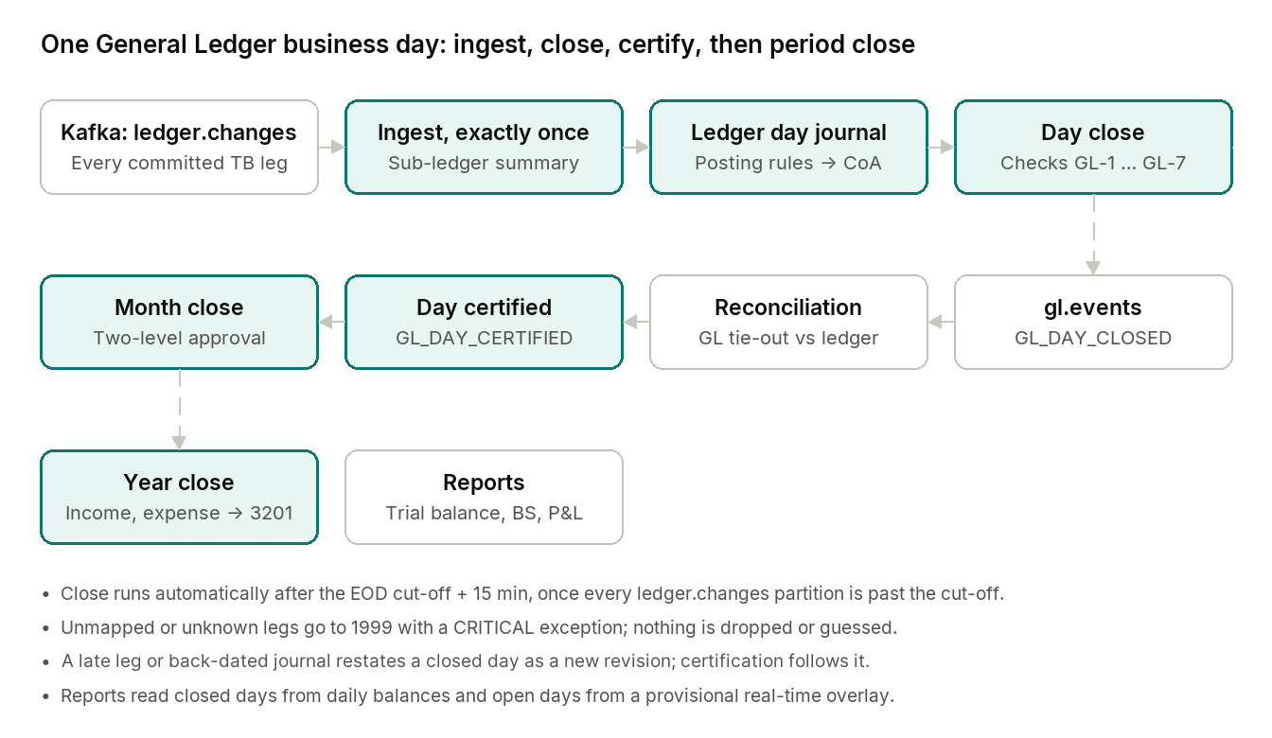
One General Ledger business day · ingest, close, certify, then period close
Green boxes are the GL's own steps. The day closes by itself after the EOD cut-off, reconciliation certifies it from the outside, and reports read the closed day's balances. A month can close only when all its days are certified.
What the GL closes, and who confirms it
Step | What happens | Example
Day close | After the EOD cut-off plus 15 minutes, once every ledger.changes partition is past the cut-off: derive the ledger day journal, daily balances and control totals, then run checks GL-1 to GL-7 (balanced journals, zero trial balance, GL equals the ledger for trust and system accounts, must-be-zero accounts). | 9 Oct closes with one journal of 110,237,509 poisha on each side
Certification | Reconciliation compares the GL control totals with its own ledger projection (the GL tie-out) and publishes the result on recon.events; the GL marks the day certified. The GL never certifies itself. | GL_DAY_CERTIFIED for 9 Oct
Reports | Trial balance, balance sheet and P&L: closed days from daily balances, open days from a provisional real-time overlay. There is no journal file export. | October 2026 trial balance
Month close | All days closed and certified, no pending journals, no open critical exceptions; two approvals. | October 2026 closed
Year close | All months closed; income and expense balances move to retained earnings (3201). | FY2026-27 closes after June 2027
What the GL talks to
Service or system | What flows
Ledger service | ledger.changes (every committed leg); account-type, batch balance and system-balance-sheet reads (read only)
Wallet service | wallet.events: the wallet type of each new account
Treasury service | treasury.events: trust-account interest, e-money redemptions, reasons for manual ledger journals
Finance-ops (reconciliation) | recon.events: the GL tie-out result; reads GL control totals and the chart of accounts
Admin service | Reference data (EOD cut-off, fiscal year); approvals, audit events and staff notifications
Rules the GL never breaks
- It never moves money or edits TigerBeetle. A wrong e-money balance is corrected by a ledger command, which the GL then books.
- It only adds amounts the ledger posted. It never multiplies, divides or rounds money.
- Ledger-controlled accounts (e-money liabilities, trust banks, VAT and AIT payable) take only ledger-derived lines. Manual journals, such as a bank charge, go to GL-only accounts and need maker-checker approval.
- Posted journals never change: corrections are new journals, and nothing dated in a closed month changes.
- It holds no personal data: no phone numbers, names or NIDs.
Where it runs. A small Spring Boot service (about 384 MB) with its own Postgres schema. Two ingest replicas share the ledger.changes partitions, and scheduled jobs (day close, restatement, reports) run once across replicas through ShedLock. It is back office only: Finance uses it through the back-office portal.

8. Data stores
Each kind of data lives in the store that suits it: money in TigerBeetle, records in Postgres, fast lookups in Redis, reports in ClickHouse. No service ever writes into another service's database.
Store | Holds | Setup | Example
TigerBeetle | Balances and every money movement, reached only through the ledger service | One cluster, 6 replicas (Section 16) | Rahim's balance: 1,494.25 Tk
Postgres: transaction DB | Transaction intent, status, outbox | Sharded: 16 logical shards on 4 Patroni clusters, daily partitions | "Rahim → Karim, 500 Tk, COMPLETED"
Postgres: other services | Wallet/KYC profiles, merchants, fee rules, limit settings | One Patroni cluster per service | Karim's KYC tier and NID status
Postgres: general ledger | Chart of accounts, posting rules, journals, daily balances, periods, reports | Own schema; kept 10 years | October 2026 trial balance
Redis: critical cluster | Idempotency keys, daily limit counters | Replicated, persistence on | "Rahim sent 3,500 Tk today"
Redis: cache cluster | Copy of every wallet's status | Rebuildable from Kafka (Section 14) | "Karim: active, tier 2"
ClickHouse | Statements, reports, analytics | Fed from Kafka | Rahim's last 90 days of history
OpenSearch (optional) | Search for customer-care staff | Fed from Kafka | Find a transaction by phone number
Why the transaction database is sharded. At 20,000 TPS, each payment writes about three rows: the intent, the status update and the outbox row. That is roughly 60,000 writes per second, more than one Postgres server should carry. Sharding splits the data across several servers by wallet ID.
Example of sharding. Rahim's wallet ID is run through a hash function, which always gives the same shard number, say 7. Every transaction Rahim sends is stored on shard 7. Shards 0–3 sit on Postgres cluster A, shards 4–7 on cluster B, and so on. Starting with 16 logical shards on 4 physical clusters lets you later move shards to new servers without changing the application.
Why two Redis clusters. Idempotency keys and limit counters protect money: losing them could allow a double payment or a limit breach. The wallet status cache is disposable. Keeping them apart means a problem in the cache can never damage the protection.
Alternatives considered. Citus (sharding inside Postgres) is a reasonable option if the team prefers not to shard in application code. Distributed SQL databases such as YugabyteDB or CockroachDB were not chosen for the payment path, because their cross-node commits add delay to every write.

9. How services talk: sync and async
A call is synchronous (sync) if its answer can change whether money moves; it is asynchronous (async) if it only reacts after money has moved. The transaction orchestrator — the "supervisor" that coordinates each payment — follows this rule strictly.
- Sync is like a phone call: the orchestrator asks, then waits for the answer. The customer is waiting too, so every sync call adds delay.
- Async is like a notice on a board: the orchestrator posts it and moves on. Other services read it later. The customer already has their answer.
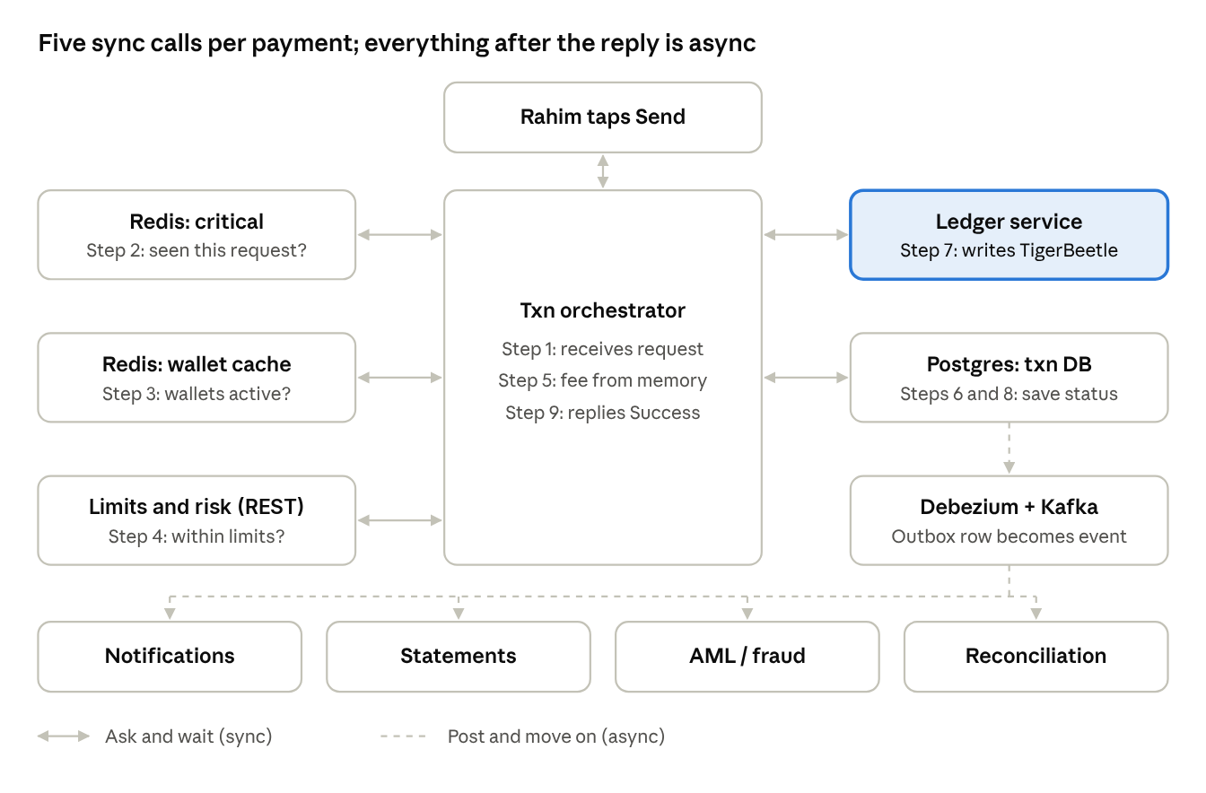
Orchestrator calls during one payment · sync and async
The orchestrator never calls the back-office services itself. It writes an outbox row in step 8, and Debezium and Kafka deliver the news after Rahim already has his answer.
Every connection on the payment path
From → To | Sync or async | How | Why
App → API gateway → orchestrator | Sync | HTTPS/REST | The customer waits for "Success" or "Failed"
Orchestrator → Redis (critical) | Sync | Redis client | Must spot a duplicate request before anything else
Orchestrator → wallet status | Sync, served from the Redis cache | Redis client | Can't move money from a blocked wallet
Orchestrator → limits and risk | Sync | REST (JSON) | Over-limit or fraud must be stopped before money moves
Orchestrator → fee rules | Sync, served from in-process memory | Caffeine | The fee is part of the same linked transfer
Orchestrator → transaction DB | Sync | JDBC | Save the intent before money moves; save the outcome after
Orchestrator → ledger service → TigerBeetle | Sync | REST (JSON); the ledger service then uses the TigerBeetle Java client | This is the money movement itself
Outbox → Debezium → Kafka | Async | Change data capture | Publishes the news without slowing the payment
Kafka → notifications, statements, AML, reconciliation | Async | Kafka consumers | They only react to a finished payment
ledger.changes → general ledger | Async | Kafka consumer; offsets stored in its own Postgres | Books every leg exactly once, after the payment
Wallet and fee services → Kafka → limits, cache-loader, orchestrator fee copy | Async | Its own outbox | e.g. "KYC upgraded" raises limits
Why wallet status and fee rules come from caches. In a simple design, the orchestrator would phone the wallet service and the fee service on every payment. At 20,000 TPS, each extra network call adds delay and one more thing that can fail. So the orchestrator reads wallet status from a full copy in Redis and fee rules from its own memory. Section 14 explains how these copies stay correct.
Example. Rahim's payment makes four sync trips that matter: Redis (duplicate check and wallet status), limits and risk, Postgres (twice) and the ledger service, which writes to TigerBeetle. Karim's SMS, Rahim's statement update and the fraud scan all happen afterwards, through Kafka.

10. Data flow 1: P2P send money
The rule for every payment is: write the intent first, move the money second, record the outcome third, and only then tell the customer "Success." Here is Rahim sending 500 Tk to Karim, step by step.
Before the payment: the confirmation screen. Rahim types Karim's number. The app looks up the wallet and shows "Send 500 Tk to Karim Ahmed? Fee 5.75 Tk." Rahim enters his PIN and taps Send. The app creates a unique request ID, the idempotency key, for example req-7f3a9c.
- Request arrives. The API gateway checks Rahim's login and device, verifies his PIN, and passes the request to the orchestrator.
- Duplicate check (Redis). The orchestrator asks: has req-7f3a9c been seen before? If Rahim's internet glitched and the app resent the request, this catches it.
- Wallet status (Redis cache). Both wallets are read in one round trip: Rahim active, tier 3; Karim active, tier 2.
- Limits and risk (REST). Rahim has sent 3,500 Tk today; adding 500 stays within his daily limit. The risk score is low.
- Fee (in-process memory). P2P fee rule: 5 Tk + 15% VAT = 5.75 Tk. The rule ID and version are saved on the intent row in step 6, so the fee can be explained later.
- Write the intent (Postgres). A row is saved: "Rahim → Karim, 500 Tk, status INITIATED." The TigerBeetle transfer IDs are derived from req-7f3a9c and saved in this row.
- Move the money (ledger service). The orchestrator sends one PostP2P command as a REST call with a JSON body. The ledger service turns it into the three linked transfers from Section 6 (principal, fee, VAT) and sends them to TigerBeetle. TigerBeetle answers "ok."
- Record the outcome (Postgres). In one database transaction, the status becomes COMPLETED and an outbox row ("P2P completed") is inserted.
- Reply. Rahim sees "Success." Total time: well under the 300 ms target.
- Background work (Kafka). Debezium reads the outbox row and publishes it. Karim gets his SMS, both statements update, the fraud system scans the payment, and reconciliation records it.
When exactly does the status change to COMPLETED? Immediately after TigerBeetle confirms the money moved (step 7), and before Rahim sees "Success" (step 9). The update only moves forward from INITIATED:
BEGIN;
UPDATE txn_intent
SET status = 'COMPLETED', completed_at = now()
WHERE txn_id = :id AND status = 'INITIATED';
INSERT INTO outbox (aggregate_id, event_type, payload)
VALUES (:id, 'P2P_COMPLETED', :json);
COMMIT;
The condition AND status = 'INITIATED' means that if two processes try to finish the same payment, only one succeeds. The other updates zero rows and does nothing, so there is never a second announcement.
What TigerBeetle can answer in step 7
TigerBeetle answers | Status becomes | Rahim sees
ok: transfers created | COMPLETED | Success
exists: same transfer ID already done (a retry) | COMPLETED, if not already | Success
A rejection, e.g. exceeds_credits (not enough balance) | FAILED, with the reason saved | "Insufficient balance"
What if a server crashes between steps 7 and 8? The money has moved, but Postgres still says INITIATED. Nothing is lost, because TigerBeetle is the source of truth. The recovery sweeper fixes the record:
- Every few seconds, it finds rows stuck at INITIATED for longer than about 30 seconds.
- It asks the ledger service to look up the transfer in TigerBeetle by its saved ID.
- Found: it marks the row COMPLETED and writes the outbox row, with the same SQL as above.
- Not found: the money never moved, so it marks the row FAILED.
Karim's SMS may arrive 30 seconds late, but the books are always right. If Rahim's app retries in the meantime, TigerBeetle answers exists and the payment completes even sooner.

11. Data flow 2: transfers to outside networks
When money leaves Bits Pay, it is first put on hold, then either released to the partner or returned, depending on the partner's answer. This is TigerBeetle's two-phase transfer, and it works like a hotel holding a deposit on your card.
It is used for every flow that waits on an outside system: sending to a bank account via NPSB or Binimoy, card payouts, remittance payouts and, from R1, bill payments through a real biller. In the MVP, bill payment and recharge are linked and instant (Section 12.1).
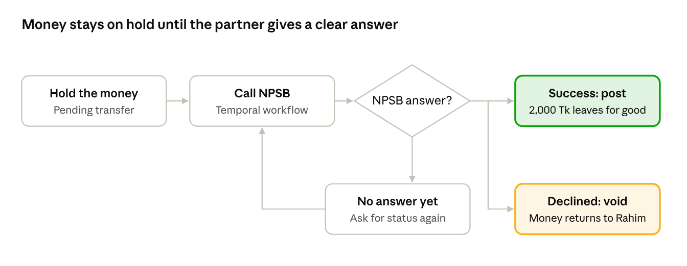
Two-phase transfer to an outside network · three outcomes
A silent partner sends the flow round the loop, not to the void box: the hold is released only when the partner clearly says no.
Example: Rahim sends 2,000 Tk to his own account at a partner bank through NPSB.
- Steps 1–6 run as in Section 10. Duplicate check, wallet status, limits, fee and intent are handled exactly the same way.
- Create a pending transfer (ledger service). 2,000 Tk plus the fee move from Rahim's wallet into a pending state toward the NPSB settlement account. Rahim can no longer spend this money, but it has not left yet.
- Start a Temporal workflow and reply. The orchestrator hands the job to a Temporal workflow and tells Rahim "Processing." It stops waiting here.
- Call the partner. The interop adapter for NPSB sends the request. Temporal retries safely if the network blips.
- Finish according to the answer. The workflow asks the ledger service to post or void the hold, as the table below shows.
- Tell everyone. An outbox event triggers Rahim's "Transfer complete" or "Transfer failed, money returned" SMS.
NPSB answers | TigerBeetle action | Result for Rahim
Success | Post the pending transfer: it becomes final | 2,000 Tk arrives in his bank account
Declined, e.g. invalid account | Void the pending transfer: the hold is released | 2,000 Tk and the fee return to his wallet
No answer, or a timeout | Ask NPSB for the status, repeatedly, until the answer is clear; then post or void | A short wait, then one of the two outcomes above
Never guess when the answer is unknown. Voiding on a timeout is the most common way wallets lose money. If the bank had actually credited Rahim, he would keep both the refund and the bank deposit. Likewise, a pending transfer's timeout in TigerBeetle must be longer than the longest time a partner can take to give a final answer. Otherwise the hold could expire on its own while the bank is still processing.
Money coming in works the other way. When Rahim adds 1,000 Tk from his bank, Bits Pay waits for the bank's confirmation first. Only then does it credit Rahim, with a single transfer from the trust settlement account to his wallet. The bank's reference number is used as the idempotency key, so a repeated confirmation never credits him twice.

12. Data flow 3: other products
Every other product reuses one of the two patterns above. Flows that stay inside Bits Pay use linked transfers (Section 10); flows that wait on an outside system use the hold (Section 11). Only the accounts and amounts change, and every product moves money through the same ledger service. All amounts below are illustrative.
Flow | Example | Linked transfers in TigerBeetle | Pattern
Cash-in | Karim gives Salma 1,000 Tk cash | Salma → Karim 1,000 Tk; commission payable → Salma 4 Tk | Linked, instant
Cash-out | Karim withdraws 500 Tk at Salma's shop | Karim → Salma 500 Tk; Karim → fee income 7.50 Tk; fee income → Salma 3 Tk commission | Linked, instant
Merchant QR | Rahim pays Nirob Store 350 Tk | Rahim → Nirob Store 350 Tk; Nirob Store → fee income 5.25 Tk (merchant fee) | Linked, instant
Bill payment (MVP) | Rahim pays a 1,200 Tk electricity bill | Rahim → biller wallet (150) 1,200 Tk; Rahim → fee income 5 Tk; Rahim → VAT payable 0.75 Tk; the simulated biller then confirms (Section 12.1) | Linked, instant (MVP); hold with a real biller from R1
Mobile recharge (MVP) | Rahim tops up his GP number with 100 Tk | Rahim → GP's biller wallet (150) 100 Tk; no fee | Linked, instant
Bank or card payout | Rahim sends 2,000 Tk to his bank | Section 11 | Hold, then post or void
Remittance in | Rahim's brother in Dubai sends 10,000 Tk | Remittance settlement → Rahim 10,000 Tk, after the partner confirms and AML screening passes | Single transfer, keyed by the partner's reference
Salary disbursement | A factory pays 5,000 workers | Factory wallet → each worker, in large batches | Linked per worker, batched
Loan disbursal and repayment | A partner bank lends Rahim 5,000 Tk | Partner settlement → Rahim; repayments go the other way | Hold for repayments that need the bank's confirmation
Cash-out in more detail. Karim, who uses a basic phone, dials the USSD code at Salma's shop and enters her agent number, 500 Tk and his PIN. The three transfers are linked: either Karim pays 500 Tk plus the fee and Salma receives 500 Tk plus her commission, or nothing happens. Salma gets an SMS confirmation and only then hands Karim the cash.
Salary disbursement in more detail. The factory uploads a file with 5,000 rows. The disbursement service checks every row (does the wallet exist, is it active), then sends them to the ledger service, which writes them to TigerBeetle in large batches; one request can carry thousands of transfers. Each row's transfer ID comes from the batch ID plus the row number, so re-running a half-finished batch never pays a worker twice. A Temporal workflow tracks progress, and the factory sees a report: 4,992 paid, 8 failed with reasons.
Busy accounts are not a problem. Nirob Store, a large biller or a super-agent may receive thousands of payments per second. Because TigerBeetle has no row locks, these "hot" accounts don't slow anything down.

12.1 Bill payment and mobile recharge (MVP)
In the MVP, Rahim pays bills and tops up phones against an internal biller catalogue. No biller, ekPay, aggregator or telco is called: a simulated provider inside the transaction service confirms each payment. The money moves in one linked ledger command, so both flows are linked and instant, like P2P (SRS BIL-011, BIL-012).
The biller catalogue
Item | MVP design
Owner | Wallet service, partner module. A biller is a partner of type BILLER with sub-type UTILITY, EDUCATION, GOVT_FEE, INTERNET_TV or MNO (mobile network operator, for recharge).
Settlement wallet | One wallet of type B (BILLER) per biller, backed by ledger account type 150 BILLER_WALLET (owner type 6 BILLER, credit-normal, debits_must_not_exceed_credits).
Biller profile | billerCode, names in English and Bangla, category, reference label and pattern, amount mode ENQUIRY, FIXED or OPEN, minimum and maximum amount, fee bearer. MNOs add MSISDN prefixes, recharge types (PREPAID, POSTPAID) and quick-pick amounts.
Seed catalogue | DESCO, DPDC, TITAS, WASA (ENQUIRY); BTCL-INT, SCHOOL-DEMO (OPEN); GP (017, 013), ROBI (018), AIRTEL (016), BANGLALINK (019, 014), TELETALK (015).
APIs | GET /v1/billers (filter by category or sub-type) and GET /v1/billers/{billerId}. Staff maintain billers through partner onboarding with maker-checker.
Cache | The wallet service writes biller:{billerId} and the MNO prefix index biller:mno-prefix:{prefix} to Redis; the transaction service reads them (data contract biller-catalogue-cache). PARTNER_UPSERTED on partner.events carries an optional biller object.
The pipeline, step by step
- Validate against the catalogue. The biller is ACTIVE, the reference matches its pattern, the amount is within its minimum and maximum (or equals the fixed amount), and for recharge the MSISDN prefix maps to the operator.
- Duplicate check (Redis critical). The idempotency key is claimed, as in Section 10.
- Wallet status (Redis cache). Rahim's wallet and the biller's B wallet in one round trip.
- Limits and risk (REST). BILL_PAY or RECHARGE against Rahim's tier limits.
- Fee (in-process memory). PLN-BILL-STD or PLN-RECHARGE-NONE.
- Write the intent (Postgres). Status INITIATED; the txnRef starts with BP or RC.
- Move the money (ledger service). Command 18 post-bill-payment or 19 post-recharge: linked transfers from 100 CUSTOMER_WALLET to 150 BILLER_WALLET (principal 1017 BILL_PAY_PRINCIPAL or 1018 RECHARGE_PRINCIPAL), plus FEE 2001 and VAT 2002 legs when the plan charges a fee.
- Confirm with the simulated provider. After the ledger answers ok, the SimulatedBillerClient confirms in-process, with no HTTP call, and returns a providerReceipt (SIM-BP-<txnRef> or SIM-RC-<txnRef>), plus a 20-digit token for prepaid electricity.
- Record the outcome and reply. COMPLETED and the outbox row in one database transaction; Rahim sees "Success" with the receipt.
When the simulated provider says no. Reserved test references ending in 0000 are rejected. The transaction service then posts post-reversal (reason SYSTEM_ERROR) for the same transfers, and the payment ends FAILED with PROVIDER_REJECTED; Rahim gets the amount and fee back. There is no PENDING state in the MVP.
Bill enquiry. For ENQUIRY billers the app first calls POST /v1/bills:enquire. The simulated provider returns a synthetic customer name, a due date and a due amount derived from the bill reference, so the same reference always gives the same amount. Paying a different amount is refused with 422 BILL_AMOUNT_MISMATCH.
Worked example. Rahim pays a 1,200 Tk DESCO electricity bill. The ledger service sends TigerBeetle three linked transfers:
Transfer | From (debit) | To (credit) | Amount (poisha) | Amount (Tk)
T1 principal (code 1017) | Rahim's wallet (100) | DESCO's biller wallet (150) | 120,000 | 1,200.00
T2 fee (2001) | Rahim's wallet | Fee income | 500 | 5.00
T3 VAT (2002) | Rahim's wallet | VAT payable | 75 | 0.75
A 100 Tk GP recharge is a single principal transfer (code 1018) from Rahim's wallet to GP's biller wallet, with no fee.
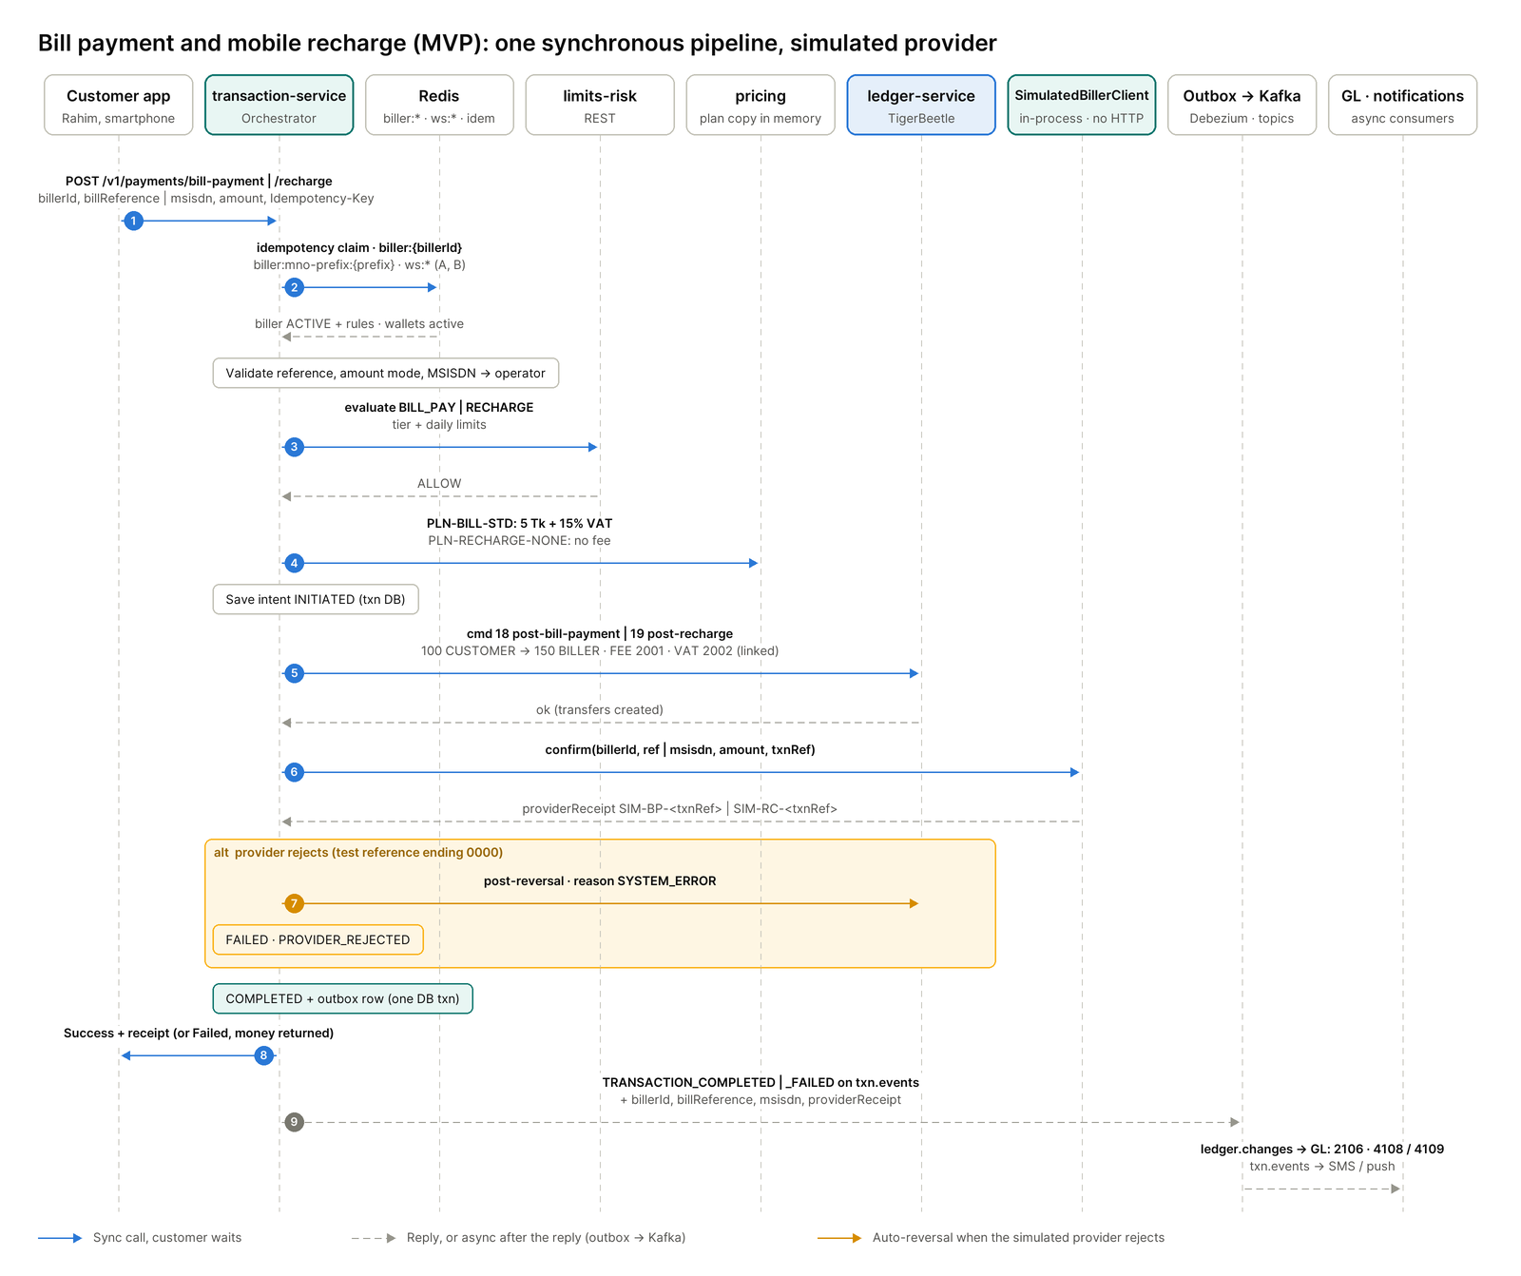
Bill payment and mobile recharge (MVP) · one linked ledger command, then the simulated provider confirms
Blue arrows are the synchronous path while Rahim waits; the amber box is the auto-reversal when the simulated provider rejects. Everything after the reply travels through the outbox and Kafka.
What the rest of the system sees
Area | MVP behaviour
txn.events | TRANSACTION_COMPLETED and TRANSACTION_FAILED gain optional fields billerId, billReference, msisdn and providerReceipt, set for BILL_PAY and RECHARGE only.
General ledger | Every 150 BILLER_WALLET leg books to 2106 E-money liability - billers. The fee on command 18 books to 4108 Fee income - bill payment, the fee on command 19 to 4109 Fee income - recharge.
Pricing plans | PLN-BILL-STD (BILL_PAY): 5 Tk flat (500 poisha), paid by the payer, VAT 15% of the fee, no commission. PLN-RECHARGE-NONE (RECHARGE): no fee, operator bearer, no commission. Biller commission is R1.
Customer limits | BILL_PAY: 10 Tk to 50,000 Tk per payment; 100,000 Tk and 20 payments a day. RECHARGE: 10 Tk to 1,000 Tk per recharge; 5,000 Tk and 20 recharges a day.
New errors | BILLER_NOT_FOUND, BILLER_INACTIVE, BILL_REFERENCE_INVALID, BILL_AMOUNT_MISMATCH, BILL_AMOUNT_OUT_OF_RANGE, MSISDN_INVALID, OPERATOR_MISMATCH, PROVIDER_REJECTED.
Switches and actors | FEATURE.BILL_PAY and FEATURE.RECHARGE. Customer-initiated only; agent-assisted bill pay and recharge are R1.
From R1, when ekPay or an aggregator is connected (bitspay.billers.mode EKPAY or AGGREGATOR), bills that wait on a real biller move to the hold pattern of Section 11.

13. Event backbone: outbox, Debezium and Kafka
Every event in Bits Pay starts as a row in a Postgres outbox table, written in the same database transaction as the change it describes. Debezium reads those rows and publishes them to Kafka, so an event can never be lost or sent for a change that didn't happen.
Why an outbox instead of publishing directly? Suppose the orchestrator saved COMPLETED and then sent a Kafka message itself. If it crashed between the two, Karim would never get his SMS. If it sent first and the save failed, Karim would get an SMS for a payment that didn't happen. Writing both rows in one transaction removes both risks.
How Debezium works. Postgres keeps a log of every change it makes, the write-ahead log (WAL). Debezium reads that log, picks out new outbox rows and publishes each one to the right Kafka topic. Its outbox event router does the routing. There is one Debezium connector per database shard.
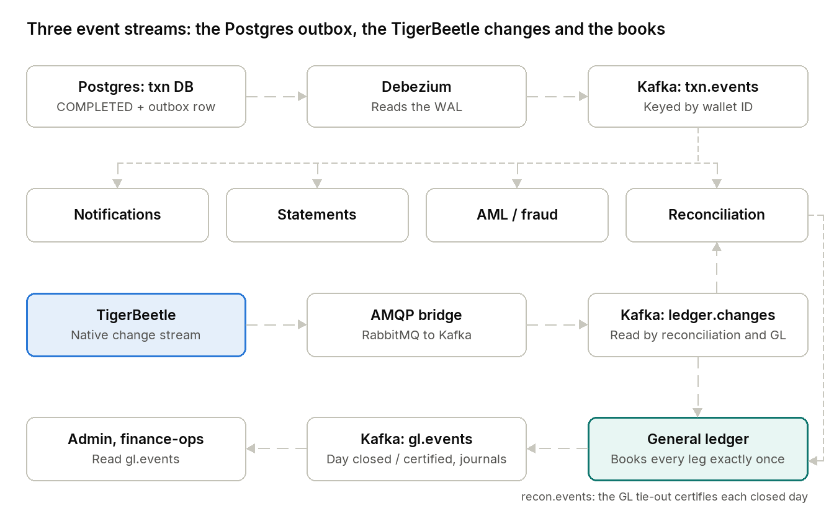
Event flow · Postgres outbox, TigerBeetle change stream and the books
The top stream tells every back-office service that Rahim's payment completed. The bottom stream lets reconciliation check that the ledger agrees and feeds the general ledger, which publishes gl.events and is certified by reconciliation's tie-out on recon.events.
Example event for Rahim's payment, as it lands in Kafka:
{
"eventId": "evt-91c2",
"type": "P2P_COMPLETED",
"txnId": "txn-55810",
"from": "wallet-Rahim",
"to": "wallet-Karim",
"amountPoisha": 50000,
"feePoisha": 575,
"at": "2026-10-08T14:03:22Z"
}
Main topics
Topic | Published by | Key | Read by
txn.events | Transaction service outbox | Sender wallet ID | Notifications, statements, AML, reconciliation
wallet.events (compacted) | Wallet service outbox | Wallet ID | Cache-loader (repairs the Redis copy), limits, general ledger
fee.rules (compacted) | Fee service outbox | Rule ID | Every orchestrator pod's in-memory fee copy
disbursement.events | Disbursement service outbox | Batch ID | Notifications, corporate reports
ledger.changes | TigerBeetle change stream | Account ID | Reconciliation, general ledger
gl.events | General ledger outbox | Business date or account code | Finance-ops, admin
recon.events | Reconciliation outbox | Run ID | General ledger (the GL tie-out certifies a day)
treasury.events | Treasury service outbox | Trust account ID | General ledger
*.dlq | Any consumer | — | Operations team
A compacted topic keeps only the latest event per key, so it doubles as a complete, current copy of the data.
Rules every consumer follows
- Process each event at most once in effect. Kafka may deliver an event twice. Consumers record each eventId they handle and skip repeats, so Karim never gets two SMS messages.
- Keep order where it matters. Events with the same key go to the same partition and arrive in order. That is why txn.events is keyed by wallet ID: Rahim's statement lines arrive in the right order.
- Park bad events, don't block. An event that keeps failing goes to a dead-letter topic (DLQ) for a person to inspect, instead of blocking every event behind it.
- Use registered schemas. Event formats are registered in Apicurio, so a producer cannot break its consumers by changing a field.
A second, independent check on the ledger. Debezium cannot read TigerBeetle. TigerBeetle has its own change data capture output; recent versions publish to AMQP (RabbitMQ), and a small bridge forwards it to the ledger.changes topic. Reconciliation compares this stream with txn.events. Every completed transaction must appear in both, with the same amounts. The general ledger reads the same stream to keep the books (Section 7).

14. Caching design
Small data that sits on the payment path is kept as a complete copy, so there are no cache misses. Only data where a miss is cheap and harmless uses a time-limited (TTL) cache. Balances are never cached.
Data | Where it lives | Kept fresh by
Fee rules (a few MB) | In each orchestrator's own memory (Caffeine) | fee.rules topic
Status of every wallet (~80 million) | Full copy in the Redis cache cluster, no TTL | wallet.events as the repair path; the wallet service writes through on every change
Busiest merchant and agent wallets | A tiny in-process cache in front of Redis, a few seconds' expiry | Expiry
Biller catalogue (MVP) | Redis keys biller:{billerId} and biller:mno-prefix:{prefix}, written by the wallet service | Write-through on every change; PARTNER_UPSERTED on partner.events
Display data (recipient name, profile picture) | Redis, cache-aside with a TTL of hours | TTL; a miss just fetches from the wallet service
Balances | Never cached | TigerBeetle only
Why not a TTL cache for wallet status? A TTL cache holds only recently used wallets, so others miss. One miss costs only 2–5 ms, but misses add up. At 20,000 TPS with two wallets per payment, a 10% miss rate sends 4,000 lookups per second to the wallet service. After a cache restart, the miss rate jumps toward 100% and can overwhelm it. In P2P, receivers like Karim are often inactive wallets, so they miss most.
How 80 million wallets fit in about 2 GB. A wallet's status is tiny: version, active or blocked, KYC tier, a few flags, about 10 bytes. Stored as one Redis key per wallet, overhead pushes this to 100–150 bytes. Grouping wallets into small hashes — "bucketed hashes" — lets Redis use its compact listpack encoding, bringing it down to roughly 15–25 bytes:
Key: ws:{walletId / 1000} e.g. ws:88123
Field: walletId % 1000 e.g. 457
Value: "version:status:tier:flags" e.g. "8812:A:2:0"
Set hash-max-listpack-entries above the bucket size (for example 1024 for buckets of 1,000) and benchmark bucket sizes between 500 and 1,000 with real data.
Keeping the copy correct
- Apply changes in order, newest wins. Each wallet row in Postgres has a version number that rises on every change. The cache loader applies an event only if its version is newer, so a late or repeated event can't overwrite fresh data:
-- KEYS[1]=bucket key, ARGV[1]=field, ARGV[2]=new version, ARGV[3]=new value
local cur = redis.call('HGET', KEYS[1], ARGV[1])
if cur then
local v = tonumber(string.match(cur, '^(%d+)'))
if v >= tonumber(ARGV[2]) then return 0 end
end
redis.call('HSET', KEYS[1], ARGV[1], ARGV[3])
return 1
- Write through on every change. Whenever a wallet changes (a freeze, a KYC upgrade, a new wallet), the wallet service commits to Postgres and then immediately runs the same script against Redis. It is the only service allowed to write these keys. The Kafka event arrives seconds later, sees the same version and does nothing; if the direct write had failed, the event repairs Redis.
- Rebuild without touching production. The first load comes from a Postgres read replica; after that, the loader follows wallet.events. Because that topic is compacted, the whole cache can be rebuilt from Kafka in minutes.
- Check continuously. A job samples wallets, compares Redis with Postgres and alerts on any difference. Another alert fires if the loader falls more than a few seconds behind.
Example: a wallet is frozen. At 14:00:00 fraud ops blocks a stolen wallet. The wallet service saves BLOCKED (version 8813) and writes it to Redis within milliseconds. A payment attempt at 14:00:01 sees BLOCKED and is refused. The Kafka event arrives at 14:00:03 and is ignored as already applied.
Handling the rare miss (for example, a brand-new wallet whose event hasn't arrived yet)
- Read sender and receiver in one round trip (HMGET or pipelining).
- If 500 requests miss on the same wallet at once, send only one lookup to the wallet service and share its answer (single-flight).
- Protect the fallback with a short timeout, a concurrency limit and a circuit breaker (Resilience4j).
- Cache "no wallet with this number" for about a minute, so mistyped or scanned numbers can't flood Postgres.
- If both Redis and the wallet service are down, refuse the payment with "please try again." Never move money on an unknown status.
Free warm-up from the app flow. The confirmation screen ("Send 500 Tk to Karim Ahmed?") already looks up Karim before Rahim enters his PIN. Any cache-aside data, such as Karim's display name, is loaded by the time the payment arrives.
Keeping the fee copy correct (the orange A–E path in the Section 4 diagram)
- No copy in the orchestrator's Postgres. The rules live in the fee service's Postgres (the source of truth) and in the compacted fee.rules topic (a lasting copy of the latest version of every rule). A third copy would only be one more thing to keep in sync; payments read from memory either way.
- Start-up. A new pod loads all active rules from the fee service (GET /v1/pricing/plans?status=ACTIVE), then reads fee.rules from the beginning with its own consumer group. It reports not ready, and takes no payments, until the rules are loaded. If the fee service and Kafka are both down, that pod stays not ready and the other pods carry the traffic.
- Changes switch at the same moment. Each rule version has an effectiveFrom time and is published ahead of it, for example “new fee from 00:00 tomorrow”. Pods receive the event a few hundred milliseconds apart, but all switch together, so two pods never charge different fees for the same payment.
- Store what was charged. Each payment saves feePoisha, vatPoisha, ruleId and ruleVersion. The fee service keeps every rule version permanently, so a dispute or audit can always answer “why 5.75 Tk?”.
- Watch the lag. Alert if any pod falls behind on fee.rules or fails to load it; a pod with old rules would charge the wrong fee without any error.
Wallet status is handled differently because it is about 80 million records, too big for every pod's memory, so it lives once in the shared Redis cache.

15. Reliability and failure handling
The system is built so that any request can be safely repeated and any component can fail without creating or losing money. When a money decision can't be made safely, the payment is refused; when only a follow-up reaction fails, it is delayed, not lost.
Three layers of duplicate protection
Layer | Protects against | Example
Idempotency key in Redis | The app resending a request | Rahim's phone retries req-7f3a9c; the second request is recognised
Transfer ID in TigerBeetle | Any retry that slips past Redis | TigerBeetle answers exists; money moves once
Event ID in each consumer | Kafka delivering an event twice | Karim gets one SMS, not two
The TigerBeetle layer is the one that guarantees correctness. The Redis layer is there to reject duplicates early and cheaply.
What happens when something breaks
Failure | What the system does | What Rahim notices
Orchestrator crashes before TigerBeetle | Sweeper finds INITIATED, TigerBeetle has no transfer, marks FAILED | Error; a retry works normally
Orchestrator crashes after TigerBeetle, before Postgres | Sweeper finds the transfer, marks COMPLETED | Short delay or retry, then Success
A Postgres primary fails | Patroni promotes a replica in seconds; only that shard's payments are affected | A few failed requests, retried
One TigerBeetle replica fails | The cluster continues while a majority of replicas is up | Nothing
Debezium or Kafka is down | Payments continue; outbox rows wait and are published on recovery | SMS and statement arrive late
Redis cache cluster is down | Wallet status falls back to the wallet service, with limits on load | Slightly slower payments
Redis critical cluster is down | Limits can't be checked, so payments pause | "Please try again"
A partner bank goes silent | The hold stays; Temporal keeps asking for status | "Processing" until resolved
Eid-day traffic surge | Stateless services scale out; the gateway rate-limits per user and channel | Normal service, or a polite "busy, try again" at the extreme
Why refuse rather than guess? If limits can't be checked, letting payments through risks breaching Bangladesh Bank limits and helping fraud. Refusing for a few minutes is a service problem. Moving money wrongly is a financial and regulatory problem.

16. Deployment, high availability and disaster recovery
Bits Pay runs across three on-prem sites in Bangladesh: a primary data center and a nearby secondary in the same metro area, which share live traffic, plus a distant disaster recovery (DR) site. The exact placement of TigerBeetle replicas still needs validation with TigerBeetle (see the end of this section).
Site | Role | Example
DC1, primary | Serves live traffic | A Tier III/IV facility in Dhaka
DC2, metro secondary | Serves live traffic; takes over all of it if DC1 fails | A second facility a few kilometres away, with a round trip of a few milliseconds
DR site | Warm standby for a regional disaster | A facility in another city
Where each component runs
Component | How it is deployed | If a whole site fails
Stateless services (orchestrator, wallet, limits…) | Kubernetes (OpenShift or RKE2) in DC1 and DC2 | The other site absorbs the load; Kubernetes adds pods
TigerBeetle | 6 replicas on dedicated bare-metal servers with NVMe drives | Continues if a majority of replicas survives
Postgres | Bare metal; Patroni with a synchronous replica in the other metro site and an asynchronous replica at DR | Patroni promotes the synchronous replica, with no data loss
Redis | Cluster mode with replicas across DC1 and DC2 | Replicas promoted; the cache can also be rebuilt from Kafka
Kafka | A cluster per site; MirrorMaker 2 copies topics to DR | Consumers resume from their last saved position
Temporal | Clustered, with its own Postgres | Workflows resume where they stopped
General ledger | Kubernetes; 2 ingest replicas share the ledger.changes partitions; jobs run once through ShedLock | Resumes from the offsets stored in its own Postgres; payments are not affected
Why TigerBeetle and Postgres run outside Kubernetes. They need fast local disks and predictable performance. Dedicated servers make both easier to guarantee and simpler to troubleshoot at 3 a.m.
The open question: TigerBeetle replicas and the DR site. TigerBeetle uses synchronous consensus: each commit waits until a majority of replicas confirms it. Replicas in DC1 and DC2 add only a few milliseconds. A replica at a distant DR site would add that site's round-trip time to every transfer. The design therefore depends on the recovery targets:
- If zero data loss at DR is mandatory (RPO = 0), some replicas must sit at DR and every payment gets slower. Benchmark the latency.
- If a few seconds of data loss at DR is acceptable, DR can be fed asynchronously, and the payment path stays fast.
This is the one design decision to confirm with TigerBeetle directly, together with Bangladesh Bank's business continuity requirements, before ordering hardware.

17. Security and compliance
Security is layered so that no single mistake exposes money or customer data, and compliance rules are enforced in code, not left to manual checks.
Area | Control | Example
Customer login | PIN plus device binding; OTP for a new device | Someone with Rahim's PIN on a different phone must pass an OTP first
PIN protection | PINs are encrypted in the app and only ever checked inside an HSM (hardware security module) | No server, log or engineer ever sees Rahim's PIN
Traffic | WAF at the edge; mTLS (mutually authenticated encryption) between all services | A stolen internal server certificate cannot talk to TigerBeetle
Secrets | HashiCorp Vault issues short-lived database passwords and keys | Credentials expire automatically
Staff access | Keycloak logins; maker-checker for sensitive actions | One officer requests a wallet freeze or a fee change; a second approves it
Data residency | All data stored in Bangladesh | Satisfied by the on-prem design
KYC tiers and limits | Enforced by the limits and risk service on every payment | A minimally verified wallet can't exceed its tier's daily limit
AML and reporting | Real-time rules and ML scoring; reports to BFIU through goAML | A sudden burst of incoming transfers to Karim's wallet raises an alert
E-money backing | Daily reconciliation of wallets against trust accounts (Section 6) | A mismatch triggers an immediate investigation
Audit trail | TigerBeetle transfers are immutable; Postgres keeps every status change; staff actions are logged | Any payment can be traced end to end
Books | General-ledger journals are immutable; manual journals need maker-checker; no personal data in the GL | A bank-charge journal needs a second Finance approver
TigerBeetle's immutability is a security feature in itself: a transfer can never be edited or deleted. A mistake is corrected only by a new, visible reversing transfer.

18. Observability and operations
Every payment can be traced from tap to ledger with one ID, and a short list of alerts covers the failures that matter most for money.
Tracing. OpenTelemetry attaches a trace ID to each request. If Rahim calls customer care, an engineer can follow req-7f3a9c through the gateway, the orchestrator, Postgres, TigerBeetle and Kafka in Grafana Tempo. Metrics go to Prometheus and logs to Loki.
Key alerts
Signal | Alert when | Why it matters
Payment latency (p99) | Above 300 ms for 5 minutes | Customers feel the slowdown
Payment error rate | Above normal levels | Something upstream is failing
Rows stuck at INITIATED | Any row older than a few minutes | Recovery sweeper is falling behind
Debezium/Kafka lag | Events more than a few seconds old | SMS and statements are delayed
Wallet cache lag or mismatch | Loader behind, or sampled rows differ from Postgres | A frozen wallet might still look active
Pending holds | Holds older than expected for a partner | A partner may be silent
Daily e-money reconciliation | Any mismatch, of any size | Regulatory and financial risk
GL ingest lag | ledger.changes more than 60 s behind (page at 15 minutes) | Day close waits; the books fall behind
GL unmapped posting or blocked close | Any leg booked to 1999, or a day not closed 90 minutes after the cut-off | The books are incomplete until Finance fixes the rule
GL certification | A closed day fails reconciliation's tie-out | The month cannot close
Dead-letter topics | Any new message | An event needs a person to look at it
Operating practices
- Load-test before Eid at 1.5–2 times the expected peak, including a simulated data center failure.
- Practice failover regularly: Postgres, TigerBeetle replicas, Kafka and a full DR switchover, with written runbooks.
- Release safely: canary deployments, where a new version first takes a small share of traffic, and feature flags to switch new products on gradually.

19. Open decisions and next steps
Eleven items need owners before detailed design starts. The first, recovery targets, affects hardware purchasing, so it comes first.
- ☐ Agree recovery targets (RPO and RTO) for the ledger with business and compliance, then confirm the TigerBeetle replica layout with TigerBeetle (Section 16).
- ☐ Benchmark TigerBeetle commit latency between DC1, DC2 and the DR site on the real network.
- ☐ Choose between application-level sharding and Citus for the transaction database (Section 8).
- ☐ Confirm the Redis edition and its license terms with legal (Section 5).
- ☐ Confirm that the team will operate Temporal, or choose an alternative for long-running workflows.
- ☐ Benchmark wallet-status bucket sizes and memory with real data (Section 14).
- ☐ Confirm the provisional chart of accounts v0 (56 accounts), the posting rules v1 and the transaction codes with finance (Sections 6 and 7).
- ☐ Confirm the fiscal-year start (Section 7).
- ☐ Map every product's limits, fees and reporting to Bangladesh Bank and BFIU rules with compliance.
- ☐ Agree the MVP pilot audience and exit criteria, sign off the seed biller and MNO catalogue, and confirm the MVP fee and limit values (SRS B-24 to B-26; Section 3).
- ☑ Decided: MVP GL days close on their control checks and stay uncertified; no month closes in the MVP. At R1 go-live reconciliation certifies every MVP day before the first month close (Section 7; SRS A-45).
- ☑ Decided (MVP decisions, 14 Oct 2026): customers are onboarded by back-office staff in a single step without maker-checker; customers transact over the REST API without a PIN (PIN, OTP and step-up from R1); no biller payout in the MVP; one fee plan per product (bill payment payer-borne, recharge free); regenerating the GL seed files (GL work package WP-CR-2) is MVP-blocking (SRS A-43 – A-46, B-26).

20. Glossary
Term | Meaning in plain words
Async (asynchronous) | Post a message and move on; someone handles it later
Cache-aside | Look in the cache first; on a miss, fetch from the source and store a copy
CDC (change data capture) | Automatically turning database changes into events
Compacted topic | A Kafka topic that keeps only the latest event per key
Debezium | A tool that reads a database's change log and publishes events to Kafka
Double-entry | Every money movement debits one account and credits another by the same amount
HSM | Tamper-proof hardware that stores keys and checks PINs
Idempotency key | A unique ID that makes repeating a request safe
Interop adapter | The service that talks to one outside network, such as NPSB
Kafka | A system that stores events in order and delivers them to many readers
KYC | Know Your Customer: verifying who a customer is
Linked transfers | Several transfers that all succeed or all fail together
Microservice | A small program that does one job and owns its own data
MFS | Mobile financial service, a mobile wallet
NPSB, Binimoy | Bangladesh's interbank and interoperable payment networks
Orchestrator | The service that coordinates each payment step by step (the "supervisor")
Outbox | A table where events are written in the same transaction as the change they describe
p99 | The time within which 99 of every 100 requests finish
Pending transfer (hold) | Money reserved but not yet moved; later posted or voided
Poisha | One hundredth of a taka; amounts are stored in poisha
REST API (JSON) | A common way for services to talk over HTTPS: each request is a web call (such as POST) whose data is sent as JSON, a readable text format
RPO / RTO | How much data you can afford to lose / how fast you must be back after a disaster
Shard | One slice of a large database, split by a key such as wallet ID
Sync (synchronous) | Ask and wait for the answer before continuing
Temporal | A tool that runs long, multi-step tasks and remembers progress through restarts
TigerBeetle | A database built only for double-entry money movements
TPS | Transactions per second
TTL | Time to live: how long a cached item is kept before it expires
Redis | An in-memory key-value store, used here for fast lookups and counters
Chart of accounts | The Operator's list of accounting accounts (assets, liabilities, equity, income, expenses), owned by the general ledger
Day close | The general ledger's end-of-day step: build the day's journal and balances, then check them
General ledger (GL) | The Operator's official books, derived from what the ledger posted
GL tie-out (certification) | Reconciliation's independent check that a closed GL day agrees with the ledger
Journal | A balanced set of debit and credit lines in the general ledger
Posting rule | Data that says which chart-of-accounts account a ledger movement belongs to
Trial balance | Every GL account with its debit or credit balance; the two sides are equal
MVP | Minimum viable product: the smaller first release before R1 (Section 3)
Biller wallet | The settlement wallet (type B, ledger account 150) that receives bill payments and recharges for one biller or operator
Simulated provider | The SimulatedBillerClient inside the transaction service, which confirms bills and recharges in the MVP without calling anyone
FEATURE switch | An admin setting that turns a product on or off, such as FEATURE.BILL_PAY

